**Q.** Write short notes on following

* + - Scrum
    - Lean Development
    - Extreme programming (XP)
    - Adaptive Software Development (ASD)
    - Feature Driven Development

* **SCRUM**

Scrum is a very popular method which has very short iterations (or sprints) which focus on delivering the working software. Scrum uses a tightly prioritized ‘backlog’ for both the sprints and the product and specifies a Product Owner role who sets the priorities. Scrum works well for long term, complex projects which require stakeholders’ feedback, which in turn greatly affects the requirement for the project.

It is the best choice when the exact amount of work cannot be estimated and the release date is not fixed.   
Scrum team has an average of 5 to 9 people in it which does not include any traditional software engineering roles like designer, tester, programmer, etc. Everyone on the team works on a set of work they have collectively committed to complete inn that sprint.

**Product Owner** is someone from product marketing or management or a key stakeholder.

**Scrum Master** is responsible for making sure the team is as productive as it could be by helping the team use the scrum process, protecting team from outside etc.

**Product backlog** is prioritized feature list containing every desires in the product.

**Sprint Planning Meeting** is held at the start of every sprint to decide on the product backlogs etc.

**Daily Scrum** is a brief meeting to help the team stay on track.

**Sprint Review Meeting** is held at the end of every sprint to show the accomplishments of the team during the sprint.

**Sprint Retrospective** is held at the end of the sprint in which the team reflect on how well the scrum is working for them and what changes they might wish to see in the scrum to make it work better.

.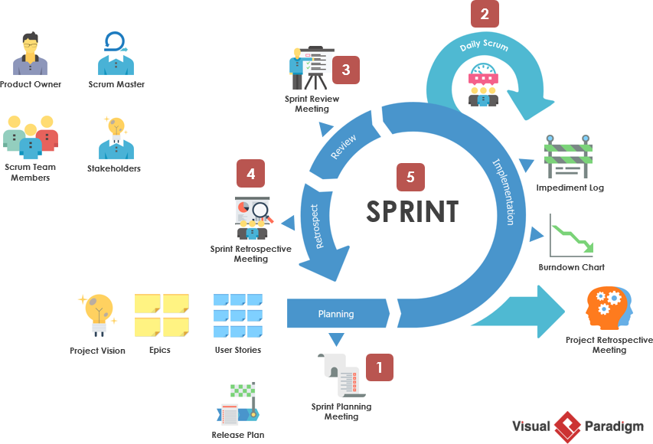

* **EXTREME PROGRAMMING**

The source of many popular agile practices, and the key founding method. A disciplined approach with high customer involvement, continuous planning, continuous testing and rapid delivery in very short intervals.

**The five values of Extreme Programming is as follows:**

**Communication :** Software development is a team game which relies on communication to transfer knowledge to every individual in the team. XP stresses on appropriate communication’s importance and face to face discussions.

**Simplicity :** It focuses on doing only the necessary thing and to avoid waste or overly complicated work/design, keeping everything as simple as possible.

**Feedback :** Through constant feedback about previous efforts, teams can improve or revise their practices.  
  
**Courage :** Courage is needed to raise organizational issues that reduce team’s efficiency and reduces the harmful things that may come to the team.

**Respect :** Members of a team need to respect each other and hoor the relationship between them.

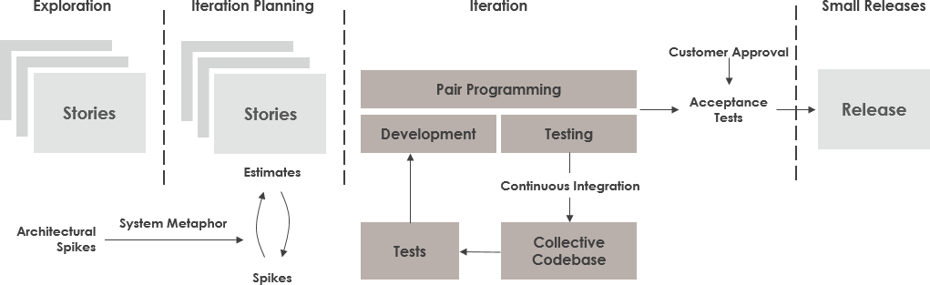

* **LEAN DEVELOPMENT**

Lean Development is an agile framework based on optimizing development resources and time, reducing the delivery time and the waste. Lean approach is also often referred to as the minimum viable product in which the minimum possible version of its product being released to the market to earn from the users about their likes and dislikes. Further features are added or removed based on the feedback thus received.

This approach allows more functionality to be delivered in less time. Unnecessary activity is eliminated, reducing the cost and empowers the development team, boosting their morale and helping with the decision making.

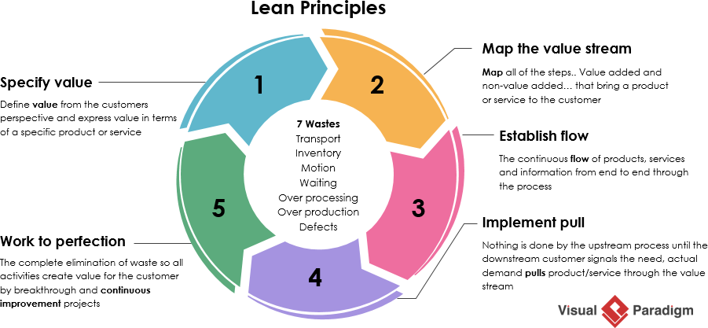

* **FEATURE DRIVEN DEVELOPMENT**

Feature driven development organizes the development of the software around making progress on features. They are similar to user stories in Scrum for example a process to push notifications for updates or a login feature are considered to be features in this methodology.

It is a simple process which allows the rapid development of the product.

It allows larger team to move products forward with continuous success and leverages pre-defined development standards, so teams are able to move at a quicker pace.

Feature Driven Development may not be feasible for smaller projects.

It is highly dependent on lead developers and has less written documentation which might cause confusion in some cases.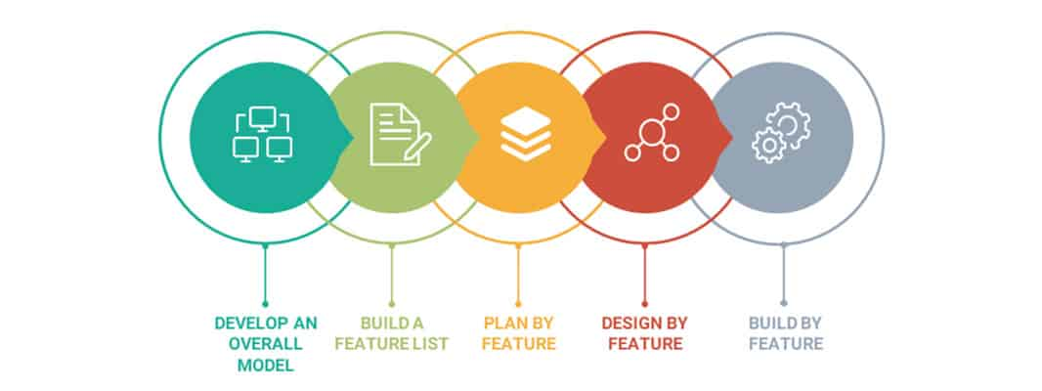

* **ADAPTIVE SOFTWARE DEVELOPMENT**

Adaptive Software Development aims to enable teams to effectively and quickly adapt to the changing requirements or the market needs through evolving their products through continuous learning or lightweight planning. It encourages teams to develop according to a three-phase process which includes speculate, collaborate and learn.

It is focused on the end users, leading to a more intuitive product.

It encourages transparency between the developers and the clients.

ASD allows for on time or even early deliveries.

It requires extensive user involvement, increasing the difficulty of development a bit.

It emphasizes on rapid iterating and continuous feedback and integrates testing into every stage, adding to the costs of the product even further.

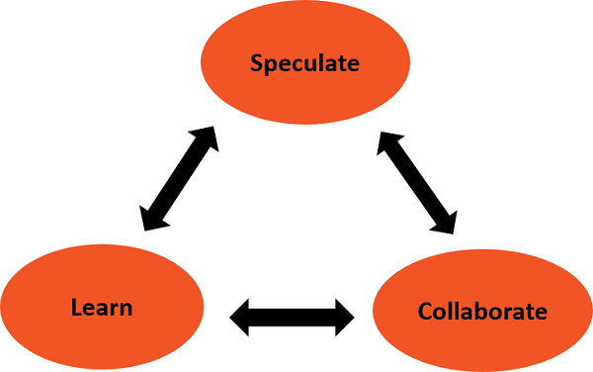

**Submitted By:**   
 **Mohan**   
 **2017UCO1667**  
 **COE 3**